Ex. No.:3 Roll No.: 21BCS023
Date :12/1/24

Use Case Diagram for User Library Management system

Aim

To create use case model for User Library Management system using CASE tools and write the use case template for each scenario

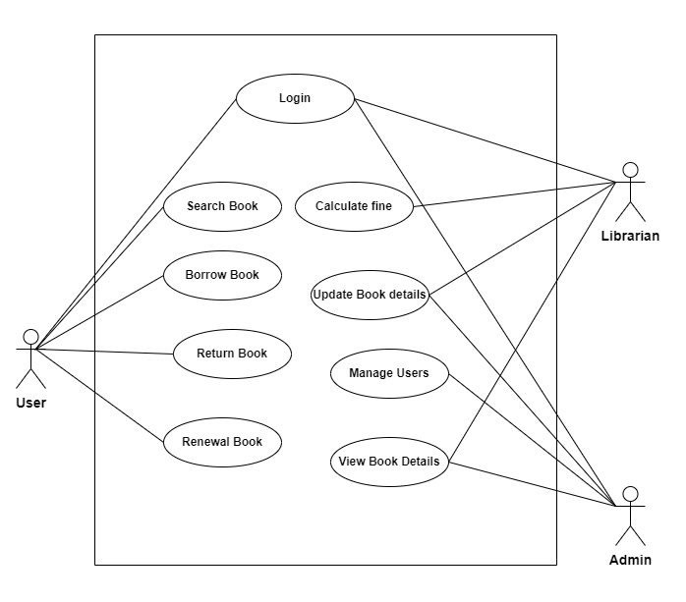

Fig:3.1 – Use Case Diagram for User Library Management system

Use Case Templates

UC - 001
Use Case Name: | Login or Register
Actors: | New users ,Register user ,Librarian ,Admin
Description: | This use case involves the process of allowing users to either log in to their existing accounts or register as new users in the User Management Library system.
Pre – conditions: | The user is not logged into the system
Post – conditions: | The user is successfully logged in, or a new user account is created
Main Success Scenario: | - User accesses the login or register page.  - user selects the "Login" option.  - Users enters valid credentials (username and password).  - System verifies the credentials.  - If valid, the system logs in the user and redirects to the user's dashboard.  - If not valid, an error message is displayed, and the user is prompted to enter correct credentials
Alternative Scenario1: | Users selects the "Register" option.  - Users provides required registration information (e.g., username, password, email).  - System validates the information.  - If valid, a new user account is created, and the user is automatically logged in.  - If not valid, an error message is displayed, and the user is prompted to correct the information.
Alternative Scenario2: | - user selects the "Forgot Password" option.  - user provides their registered email address.  - System sends a password reset link to the email.  - User clicks on the link and resets the password.

UC - 002
Use Case Name: | Search book
Actors: | User, Librarian
Description: | This use case involves the process of searching for books within the library's collection.
Pre – conditions: | - The user is logged into the system .  - The librarian is logged into the system .
Post – conditions: | The search results are displayed, and the user/librarian can view book details .
Main Success Scenario: | - User accesses the search functionality.  - User enters search criteria (e.g., title, author, ISBN).  - The system displays a list of matching books.  - User selects a book from the list to view details.
Alternative Scenario1: | - No matching books are found.  - The system displays a message indicating no results and suggests refining the search criteria.
Alternative Scenario2: | - Librarian uses an advanced search option.  - Librarian enters specific criteria (e.g., category, publication year).  - System performs an advanced search and displays relevant results.

UC - 003
Use Case Name: | Borrow Book
Actors: | User
Description: | The process of a library user borrowing a book from the library.
Pre – conditions: | - The user is logged into the system .  - The book is available in the library's collection.
Post – conditions: | The book is marked as borrowed, and the user's account is updated.
Main Success Scenario: | - Library User searches for a book and selects a book  - User requests to borrow the selected book.  - System checks the availability of the book.  - If available, the system updates the book status to "Borrowed" and assigns it to the User.  - The system updates the User's account with the borrowed book details.  - The system sends a notification to the User confirming the successful book borrow.
Alternative Scenario1: | - Librarian can override the borrowing process for special cases.  - Librarian enters a manual override to allow a book to be borrowed even if it's marked as unavailable
Alternative Scenario2: | If the book is not available, the system displays a message indicating unavailability and suggests checking back later or placing a hold

UC - 004
Use Case Name: | Return Book
Actors: | User
Description: | This use case involves the process of a library member returning a borrowed book to the library.
Pre – conditions: | - The User is logged into the system.  - The book was previously borrowed by the User.  - The book is currently marked as "Issued" to the User.
Post – conditions: | The book is marked as returned, and the User's account is updated.
Main Success Scenario: | - Library User approaches the librarian to return a borrowed book.  - Librarian verifies the user's account and the book being returned.  - Librarian scans the book's barcode or manually selects the returned book.  - System updates the book status to "Available" and removes it from the User's account.  - The system updates the User's account, reflecting the returned book.  - Librarian acknowledges the return and checks for any outstanding fines or issues.  - Librarian User's account with the return information.
Alternative Scenario1: | If the returned book has damages or is overdue, the librarian informs the User about any associated fines or penalties.

UC - 005
Use Case Name: | Update Book Details
Actors: | Librarian
Description: | This use case involves the process of a librarian updating the details of a book in the library's collection.
Pre – conditions: | - The librarian is logged into the system.  - The book exists in the library's collection.
Post – conditions: | The book details are successfully updated in the system.
Main Success Scenario: | - Librarian accesses the system for updating book details.  - Librarian selects the option to update book details.  - Librarian searches for the book by category  - System displays the book details for the librarian to review and update.  - Librarian modifies the necessary details (e.g.no.of available books,).  - Librarian confirms the changes.  - System updates the book details in the library's database.  - The system generates a confirmation message for the librarian.
Alternative Scenario1: | If the librarian enters invalid information or encounters an issue during the update, the system displays an error message and prompts the librarian to correct the information.

UC - 006
Use Case Name: | View Details
Actors: | Admin ,Librarian
Description: | This use case involves the process of viewing detailed information about a book in the library's collection and users information.
Pre – conditions: | - The admin/librarian is logged into the system .  - The book exists in the library's collection.
Post – conditions: | The admin/librarian successfully views detailed information
Main Success Scenario: | - admin/librarian accesses the system for viewing book/user details.  - admin/librarian searches for the book by title, author, or ISBN.  - System displays the book details, including title, author, category, availability status, and a brief description and the borrowed user .
Alternative Scenario1: | If the book is not found, the system displays an error message and suggests checking the search criteria or notifying the librarian.

UC - 007
Use Case Name: | Manage users
Actors: | Admin
Description: | This use case involves the process of managing user accounts within the system, including activities like creating new user accounts, updating existing user details, and deactivating or deleting user accounts.
Pre – conditions: | - The user performing the actions is authorized with administrative privileges.  - The system is accessible and operational.
Post – conditions: | User account information is successfully managed in the system.
Main Success Scenario: | - System Administrator logs into the system.  - System Administrator navigates to the "Manage Users" section.  - System Administrator performs actions such as:  - Creating new user accounts.  - Updating user details (e.g., username, email, role).  - Resetting passwords.  - Deactivating or activating user accounts.  - Assigning or modifying user roles and permissions.  - System updates the user account information in the system database.  - System generates a confirmation message for each action performed.
Alternative Scenario1: | If there are issues creating a new user account, updating details,the system displays an error message and logs the issue for technical support.
Alternative Scenario2: | - The system may have role-based access control, allowing different levels of user management permissions.  - If the user attempting to manage other users does not have sufficient permissions, the system denies access and displays an authorization error.

UC - 008
Use Case Name: | Renewal Book
Actors: | Library User
Description: | This use case involves the process of a User renewing a borrowed book to extend the borrowing period.
Pre – conditions: | - The User is logged into the system.  - The book was previously borrowed by the User.  - The book is eligible for renewal (not reserved, not overdue, etc.).
Post – conditions: | - The User is logged into the system.  - The book was previously borrowed by the User.  - The book is eligible for renewal (not reserved, not overdue, etc.).
Main Success Scenario: | - User accesses the system for renewing a borrowed book.  - User selects the option to renew a book.  - System displays a list of the member's borrowed books with their due dates.  - User selects the book to be renewed.  - System checks the book's eligibility for renewal (e.g., not reserved, not overdue).  - If eligible, the system updates the due date, and the book is marked as renewed.  - The system updates the User's account with the new due date.  - The system sends a notification to the User confirming the successful book renewal.
Alternative Scenario1: | If the book is not eligible for renewal (e.g., reserved by another member, already overdue), the system displays an error message and provides information on why renewal is not possible.

UC - 009
Use Case Name: | Calculate Fine
Actors: | Librarian
Description: | This use case involves the process of calculating fines for library members based on the overdue period and any other relevant penalty rules.
Pre – conditions: | - The system has access to the due dates of borrowed items.  - The current date is later than the due date of one or more borrowed items.
Post – conditions: | The system determines the fine amount for each overdue item.
Main Success Scenario: | - System identifies borrowed items with due dates that have passed.  - System calculates the overdue period for each item.  - The system updates the user's account with the calculated fines for each overdue item.
Alternative Scenario1: | The system may have different fine calculation rules based on the type of item (e.g., books, DVDs) or membership type (e.g., regular, premium).

Result
Thus the use case model for the User Library Management system is created using CASE tools.

